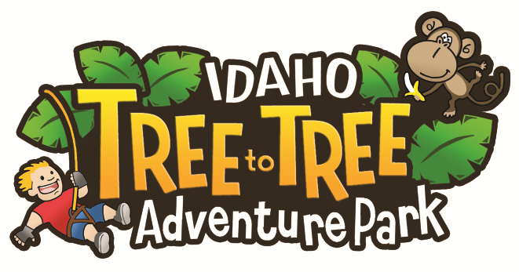
FREE ADMISSION
TUESDAY-WEDNESDAY, JUNE 18-19 2018
Please join Tree to Tree Idaho Adventure Course for its 2018 Hospitality Day Open House. As Idaho’s newest attraction, we are looking forward to meeting personnel from neighboring resort businesses and extend an exclusive offer of FREE course admission for up to two employees to enjoy our park during our Inaugural Hospitality Day.

STEP 1: We make it simple.
Choose a departure time of 10a, 12pm or 2pm on either June 18TH or 19TH
and help us celebrate the 2018 season with our Resort Community neighbors.
Receive two FREE COMPLIMENTARY ADMISSIONS* for you and/or your staff
Make your reservation today by calling 208.423.8289
STEP 2: Present this completed voucher upon check-in of your departure time.
Resort/Business Name: __________________________________________
Email Address: _________________________________________________
Employee Name: _______________________________________________
Employee Name: _______________________________________________
*Please note: This Invitation must be presented upon arrival along with photo i.d. and proof of employment. Offer valid to persons 18 and older on June 18-19 with advanced reservation by phone 208.423.8289.

